Software Requirement Specifications
Smart Library Management System



Submitted by
Name: AREE BA
Roll No. S23BINFT1M01080

Submitted to
Prof. Dr. Dost Muhammad Khan Sahb

Department of Information Technology
Faculty of Computing
The Islamia University of Bahawalpur

Meeting Details
Sr No | Details | Date | Supervisor Signature
Summary
The management of the library system in educational institutions is currently done manually. In order to search for, borrow or return books, the users should visit the library. This way of doing things is time consuming and error-prone and cannot be described as being effective. In order to resolve the above challenges, our suggestion is to create a Web-Based Library Management System (LMS). This LMS will have automated all necessary functions performed by the library such as user registration, searching, borrowing, returning, reserving, computation of fines and reports.
This Library Management System will provide a simple and friendly user interface, making it easier and faster for the users, which include students, lecturers, and librarians to perform necessary operations online. This proposed Library Management System has many advantages since it will save time, reduce costs associated with manual labor and paper usage and eliminate errors. HTML, Bootstrap, PHP and MySQL technologies will be used in creating this LMS.

Table of Contents
1. Introduction 6
1.1. Purpose 6
1.2. Scope 6
1.3. Product Perspective 7
1.4. User Characteristics 7
1.4.1 Types of Users 7
1.4.2 Skills and Experience 8
1.4.3 User Environment 8
1.5. Similar apps and systems/Literature Review 8
1.6. Proposed Technologies 8
2. Requirements 9
2.1. Function Requirements 9
2.1.1 User Management 9
2.1.2 Book Catalog Management 10
2.1.3 Book Search and Browsing 11
2.1.4 Circulation Management 11
2.2. Non-Functional Requirements 12
2.2.1 Usability Requirements 12
2.2.2 Performance Requirements 13
2.2.3 Security Requirements 13
2.2.4 Reliability and Availability Requirements 13
2.2.5 Scalability Requirements 13
2.2.6 Maintainability Requirements 13
2.2.7 Portability and Compatibility Requirements 14
2.2.8 Error Handling Requirements 14
3. Use Cases and Flow of Processes 14
3.1. Sign Up Use Case 15
3.1.1 Sign Up Activity Diagram 16
3.1.2 Sequence Diagram for Sign Up 17
3.2 User Login Use Case 18
3.2.1 Activity Diagram for Login 19
3.2.2 Login Sequence Diagram 21
3.3 Search Book Use Case 22
3.3.1 Activity Diagram for Search Book 23
3.3.2Search Book Sequence Diagram 24
3.4 Issue Book Use Case 25
3.4.1 Activity Diagram for Issue Book 26
3.5 Return Book Use Case 28
3.5.2 Return Book Sequence Diagram 30
3.6 Add New Book Use Case 31
3.6.1 Add New Book Activity Diagram 31
3.6.2 Add new Book Sequence Diagram 32
4. References 33

Currently, borrowing books, returning books, or checking the available books at Library is done manually where a person must physically visit the library to see which books are available. Person reviews the list of accessible books and borrows them if they are available; otherwise, it is pointless for the person to visit the library just to look for books if the person cannot obtain a book. The librarian verifies the person’s ID and permits the member to borrow the book, after which the librarian updates both the member database and the books database.
This requires at least one to two hours if the member is close by; otherwise, it could take longer. We have chosen to explore the implementation of an Online Library Management System. This system would be utilized by individuals to verify the availability of books and borrow them, as well as by the librarian to refresh the databases. This document aims to examine and detail the primary requirements and functionalities of the Online Library System. It emphasizes the features and services offered by a Library. The specifics of the requirements for the Online Library System and whether it meets these requirements are outlined in the use-case and supplementary specifications.
  - Purpose
The primary aim of this document is to outline the specifications for the Library Management System project. It provides a thorough explanation of both functional and non-functional requirements. This project's goal is to streamline manual library tasks like cataloging books, managing members, and tracking book issuance and returns. It offers an intuitive interface for both librarians (administrators) and library members. Additionally, it details the hardware and software interface requirements through ER models and UML diagrams.
  - Scope
The Library Management System Project involves transforming the traditional manual library system into a web-based application, enabling users to access information about their accounts, check book availability, understand borrowing limits, and explore various additional features.
The project is tailored specifically for librarians and library patrons. The product will serve as a comprehensive user interface for managing library operations and utilization by regular users. A Library Management System can be utilized by any current or new library to oversee its books, borrowing, addition, and tracking. It is particularly beneficial for any educational institution where alterations in the material can be made effortlessly based on needs.
The project can be effortlessly executed in different scenarios. New features can be added whenever needed, enabling reusability due to the flexibility present in all modules. The project is developed using Html, Bootstrap, and PHP with MySQL for the backend. Regarding performance, available tools, compatibility across platforms, libraries, cost (available at no charge), and the development process, these languages show significant compatibility.
  - Product Perspective
LMS serves as an alternative to traditional library management systems that rely on paper-based methods for documenting book and user details. The LMS will offer an enhanced book search feature and will simplify the processes of borrowing, adding, and cataloging a book in the library.
  - User Characteristics
Library Management System (LMS) is meant to serve different groups of people within the university setting. Different users have different duties, responsibilities, and interactions with the system. This section explains the users in detail:

1.4.1 Types of Users
The system recognizes three main types of users as follows:
Students (Library Members):
These include undergraduate and postgraduate students who will make use of the system in looking for books, checking whether they are available, issuing books, returning books, and viewing their history.
Faculty Members (Teachers):
These consist of university lecturers who will have similar rights as students, with an additional right to recommend research books and reservations.
Librarians / Administrators:
They comprise library staff members tasked with managing the whole system, including addition/removal of books, user account management, issuance/returning of books, reporting, and defaulter list management.

1.4.2 Skills and Experience
It is assumed that all users will have basic computer skills and can navigate the internet and fill online forms. Students and lecturers are assumed to be familiar with using smartphones and laptops in learning. It is also assumed that librarians will have intermediate computer skills and be able to operate web-based applications and perform some administrative duties. No technical skills such as programming and database management are needed from end-users.

1.4.3 User Environment
End-users will access the system via a standard web browser like Google Chrome, Mozilla Firefox, Microsoft Edge, or Apple Safari.
  - Similar apps and systems/Literature Review
There are many existing LMS like Koha, NewGenLib, and Libsys that offer sophisticated functionalities, but they are either difficult to implement (open-source software) or too costly for small educational institutes. In contrast, our proposed LMS is designed to be a lightweight and free web-based system developed especially for university libraries using only PHP and MySQL.
  - Proposed Technologies
The Library Management System will be developed using the following modern yet simple and reliable web technologies:
- Front-end: HTML, CSS, JavaScript, Bootstrap
- Back-end: PHP
- Database: MySQL (with XAMPP server)
- Operating System: Windows 7/8/10
The selected technologies are particularly advantageous as they are free and open source, thus being very applicable for this project, which requires absolutely no costs related to software license fees. The combination of HTML, CSS, JavaScript, and Bootstrap will make it possible to develop a clean, efficient, and friendly interface that will work seamlessly in both desktop and mobile versions. The usage of Bootstrap will speed up the development process by virtue of providing responsive elements and style uniformity.
PHP together with MySQL proves very effective in managing many books, users, and transactions with the minimum server load. XAMPP provides a fast setup and tests running environment for Windows platforms. The listed technologies are very popular among computer science courses and programs, so it will be very easy for future developers to modify or even redesign this application.
- Requirements
The suggested Library Management System (LMS) has been created to facilitate all the activities associated with the daily functioning of a university library. It offers a full suite of functionalities which help the users to register themselves, find the book on the Internet, and either borrow or reserve the book in the library. Moreover, librarians get an ability to maintain their book collection in an efficient manner. The system guarantees convenient access for various types of users (students, teachers, and librarians) using only one website.

  - Function Requirements
Authors The proposed Library Management System (LMS) provides the following comprehensive functional requirements:

2.1.1 User Management
FR001 – New User Registration
• Name: FR001
• Purpose: Allow new students, faculty members, and staff to create an account in the system.
• User(s): Student, Faculty, Staff
• Input: Full name, University ID/Email, Password, Phone number, User type (Student/Faculty/Staff)
• Output: Account created successfully and confirmation message sent
FR002 – User Login
• Name: FR002
• Purpose: Provide secure authentication for registered users.
• User(s): Student, Faculty, Staff, Librarian
• Input: Username/Email and Password
• Output: Successful login and access to respective dashboard.

FR003 – User Logout
• Name: FR003
• Purpose: Allow users to securely end their session.
• User(s): All users
• Input: Logout request
• Output: Session terminated and user redirected to login page
FR004 – Update User Profile
• Name: FR004
• Purpose: Enable users to modify their personal information.
• User(s): Student, Faculty, Staff
• Input: Updated phone number, address, profile picture
• Output: Profile updated successfully
FR005 – Password Recovery/Reset
• Name: FR005
• Purpose: Allow users to reset forgotten password via email.
• User(s): All users
• Input: Registered email address
• Output: Password reset link sent to email

2.1.2 Book Catalog Management
FR006 – Add New Book
• Name: FR006
• Purpose: Allow librarian to add new books to the library database.
• User(s): Librarian
• Input: Book title, author, ISBN, publisher, edition, category, price, quantity, cover image
• Output: Book added to catalogue and available for search
FR007 – Update Book Information
• Name: FR007
• Purpose: Modify existing book details.
• User(s): Librarian
• Input: Updated book information
• Output: Book record updated
FR008 – Delete Book
• Name: FR008
• Purpose: Remove a book from the system (soft delete).
• User(s): Librarian
• Input: Book ID
• Output: Book marked as deleted/inactive

2.1.3 Book Search and Browsing
FR009 – Search Books
• Name: FR009
• Purpose: Allow users to search books by multiple criteria.
• User(s): All users
• Input: Keywords (title, author, ISBN, category, publisher)
• Output: List of matching books with availability status
FR010 – View Book Details
• Name: FR010
• Purpose: Display complete information of a selected book.
• User(s): All users
• Input: Book ID
• Output: Detailed book page with description, availability, and reviews

2.1.4 Circulation Management

FR011 – Issue/Borrow Book
• Name: FR011
• Purpose: Record the issuance of a book to a user.
• User(s): Student, Faculty, Librarian
• Input: User ID, Book ID
• Output: Book issued with due date and availability updated
FR012 – Return Book
• Name: FR012
• Purpose: Record the return of a book and calculate fine if overdue.
• User(s): Student, Faculty, Librarian
• Input: User ID, Book ID
• Output: Book returned, fine (if any) calculated and recorded
FR013 – Renew Book
• Name: FR013
• Purpose: Extend the due date of an issued book.
• User(s): Student, Faculty
• Input: Issued book ID
• Output: New due date updated
FR014 – Reserve Book
• Name: FR014
• Purpose: Allow users to reserve a book that is currently issued to someone else.
• User(s): Student, Faculty
• Input: Book ID
• Output: Reservation recorded and user notified when book becomes available

  - Non-Functional Requirements
These are requirements that outline the quality attributes and constraints which will make the Library Management System function effectively.

2.2.1 Usability Requirements
The interface used by the Library Management System should be easy to use even by the novice (students and faculty members).
Navigation menus and design should be provided by the system.
Forms and pages used should have consistency in design.
The system should be usable from mobile devices and desktops.

2.2.2 Performance Requirements
Responses to users’ queries (book search, logging in and book issuing and return processes) should take a maximum of 3-5 seconds. It should have the ability to cater to 500 users at a go without reducing its efficiency. Book search result display shall take place within 2 seconds. The system shall be able to process 10,000+ book entries and 5,000+ user entries.

2.2.3 Security Requirements
All passwords provided by users shall be securely encrypted (using bcrypt or its equivalents).
The system shall support Role-Based Access Control (RBAC) to ensure that students and faculty members can only access features related to them, while librarians alone shall be allowed to modify book records and create reports. The system shall include protections against web vulnerabilities like SQL Injection, Cross-Site Scripting (XSS), and Cross-Site Request Forgery (CSRF). A session time-out of 15 minutes shall be implemented for inactive sessions. Administrators alone shall have the ability to access the database and the system backups.

2.2.4 Reliability and Availability Requirements
The system availability shall be 24 hours a day, seven days a week (24×7) except for maintenance periods. Minimum uptime of the system shall be 99%. System recovery after an unexpected shutdown shall happen within five minutes.

2.2.5 Scalability Requirements
The system should scale very easily to incorporate future growth in the number of books, users, and transactions. New modules or features can be introduced into the system without impacting existing features.

2.2.6 Maintainability Requirements
The code of the system should be structured in such a way that it is easy to maintain.
Backup and restore features for the database should be supported by the system.

2.2.7 Portability and Compatibility Requirements
The system should work on all major browsers, namely Google Chrome, Mozilla Firefox, Microsoft Edge, and Safari. The system should work on various operating systems, i.e., Windows, Linux, and macOS with the use of XAMPP.

2.2.8 Error Handling Requirements
The system must handle not only known but also unknown errors gracefully.
Any type of errors must ensure that no data loss takes place and are logged in an error log file.

- Use Cases and Flow of Processes
A use case is the formal specification of the process flow described by functional requirements. In this section, the use case diagrams at the system level and the use cases of the most critical functionalities are presented. The use case defines the interaction between an actor/user and the system, detailing preconditions, basic flow, alternative flows, and exceptions.

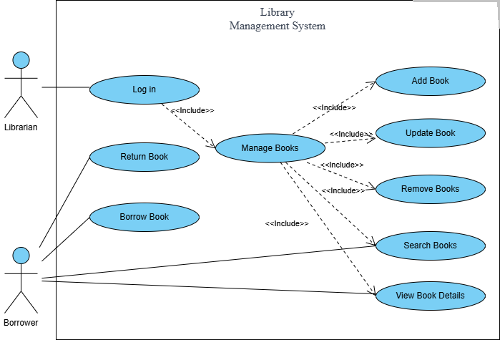
Figure 1: System Level Use Case Diagram
  - Sign Up Use Case
ID | UC001
Name | Sign Up
Description | This use case describes the process of new users (students or faculty) creating an account in the Library Management System.
Requirement(s) | FR001
Actor(s) | Admin, Borrower
Precondition | Actor must not already be a registered member of the system.
Postcondition | A new user account is created and the user receives a confirmation message.
Basic Flow | Basic Flow  - Actor enter credentials  - System validates the inputs  - Following fields are required  - Name  - Email  - Password  - Address  - Phone  - Check the proper inputs for following  - Email  - Password must be 8 character including number  - Phone Number on 11 digits  - On successful validation the system will create new user  Alternative Flow  - Admin Sign In  - Create a new User by entering data  Exceptions  - Invalid Inputs  - System unable to response

3.1.1 Sign Up Activity Diagram
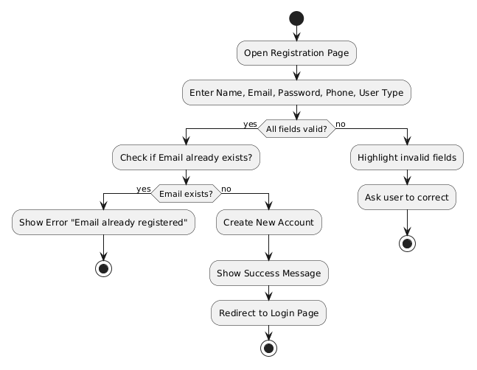
Figure 2: Sign Up Activity Diagram

3.1.2 Sequence Diagram for Sign Up
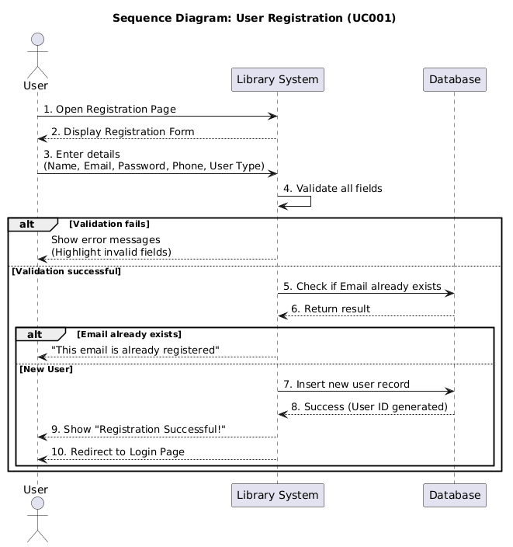
Figure 3: Sign Up Sequence Diagram

3.2 User Login Use Case
ID | UC002
Name | User Login
Description | This use case describes how registered users log into the Library Management System.
Requirement(s) | FR002
Actor(s) | Admin, Borrower
Precondition | User must have a valid registered account.
Postcondition | User is successfully logged in and redirected to their respective dashboard.
Basic Flow | Basic Flow  - Actor enters username/email and password.  - System validates credentials.  - System checks user role (Student/Faculty/Librarian).  - System grants access and displays the appropriate dashboard.  Alternative Flow  - User selects “Forgot Password” → System sends reset link to registered email.  Exceptions  - Incorrect username/password → System shows “Invalid credentials” after 3 attempts account is temporarily locked.  - Network or database error → System displays friendly error message.

3.2.1 Activity Diagram for Login
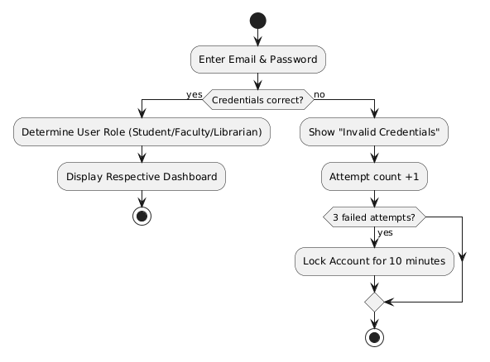
Figure 4: login Activity Diagram

3.2.2 Login Sequence Diagram
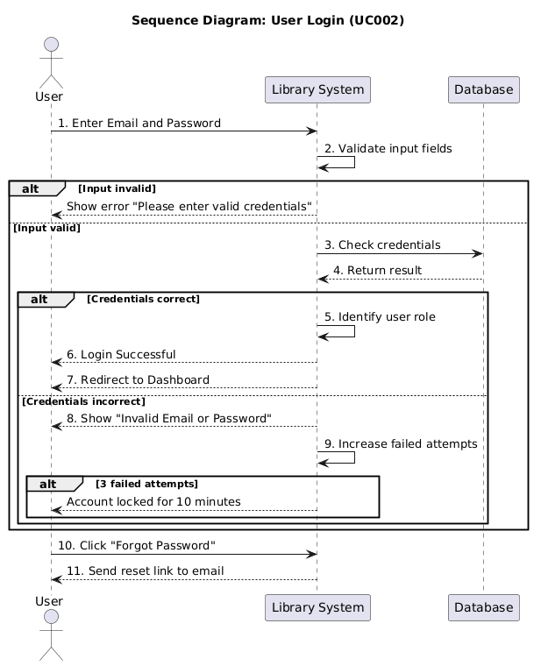
Figure 5: Login Sequence Diagram

3.3 Search Book Use Case
ID | UC003
Name | Search Book
Description | This use case allows any user to search for books in the library catalogue.
Requirement(s) | FR009
Actor(s) | Admin, Borrower
Precondition | User must be logged into the system.
Postcondition | List of matching books with availability status is displayed.
Basic Flow | Basic Flow  - Actor enters search keyword (title, author, ISBN, or category).  - System processes the search query.  - System displays list of books with details and availability.  - Actor can click on any book to view full details.  Alternative Flow  - Advanced search using multiple filters (category + author).  Exceptions  - No books found → System shows “No results found. Try different keywords.”

3.3.1 Activity Diagram for Search Book
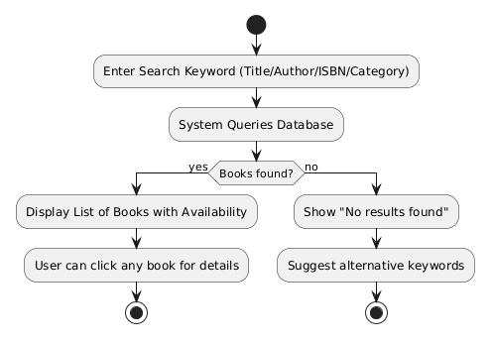

Figure 6: Search Book Activity Diagram

3.3.2Search Book Sequence Diagram
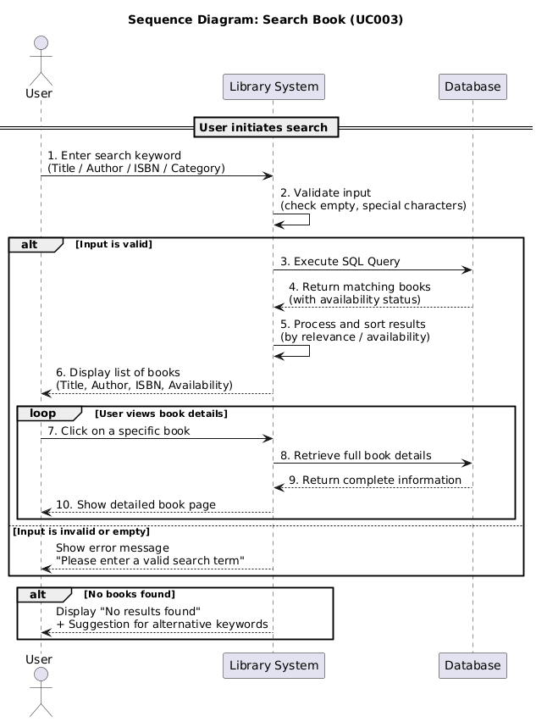
Figure 7: Issue Book Sequence Diagram

3.4 Issue Book Use Case
ID | UC004
Name | Issue Book
Description | This use case allows a user to borrow a book from the library.
Requirement(s) | FR011
Actor(s) | Admin, Borrower
Precondition | User must be logged in and the book must be available.
Postcondition | Book is issued to the user and availability status is updated.
Basic Flow | Basic Flow  - Actor searches and selects a book.  - Actor clicks “Issue Book”.  - System checks borrowing limit and due date.  - System records the transaction and updates book status to “Issued”.  - System displays due date and success message.  Exceptions  - Book is already issued → System shows “Book not available”.  - User has reached maximum borrowing limit → System shows error

3.4.1 Activity Diagram for Issue Book

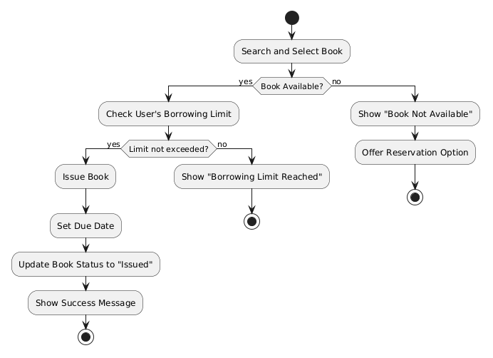
Figure 8: Issue Book Activity Diagram

Issue Book Sequence Diagram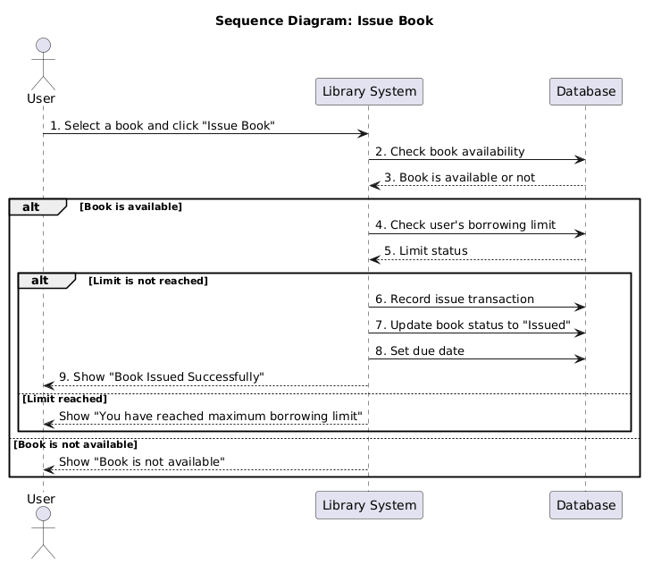
Figure 9: Issue Book Sequence Diagram

3.5 Return Book Use Case
ID | UC005
Name | Return Book
Description | This use case describes the process of returning a borrowed book.
Requirement(s) | FR012
Actor(s) | Admin, Borrower
Precondition | User must have an issued book.
Postcondition | Book is returned, fine (if any) is calculated, and availability is updated.
Basic Flow | Basic Flow  - Actor selects the issued book.  - Actor clicks “Return Book”.  - System checks due date.  - System calculates fine (if overdue).  - System updates book status to “Available” and records the return.  Exceptions  - Book is already returned → System shows error.

3.5.1 Activity Diagram for Return Book

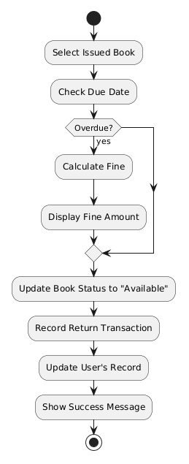
Figure 10: Return Book Activity Diagram

3.5.2 Return Book Sequence Diagram
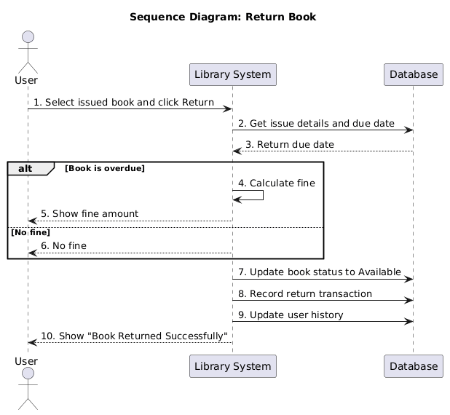
Figure 11: Return Book Sequence Diagram

3.6 Add New Book Use Case
ID | UC006
Name | Add New Book (Librarian Only)
Description | This use case allows the librarian to add a new book to the library catalogue.
Requirement(s) | FR006
Actor(s) | Admin (Librarian)
Precondition | Librarian must be logged in.
Postcondition | New book is added to the database and becomes searchable.
Basic Flow | Basic Flow  - Librarian navigates to “Manage Books”.  - Librarian enters book details (title, author, ISBN, etc.).  - System validates input.  - System adds the book to the catalogue.  Exceptions  - ISBN already exists → System shows duplicate error.

3.6.1 Add New Book Activity Diagram
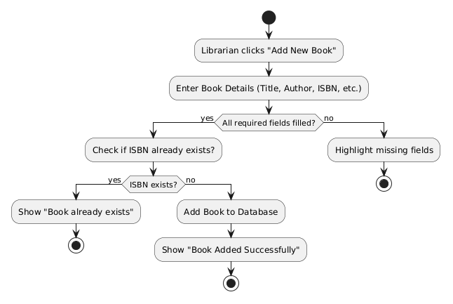
Figure 12: Add New Book Activity Diagram

3.6.2 Add new Book Sequence Diagram
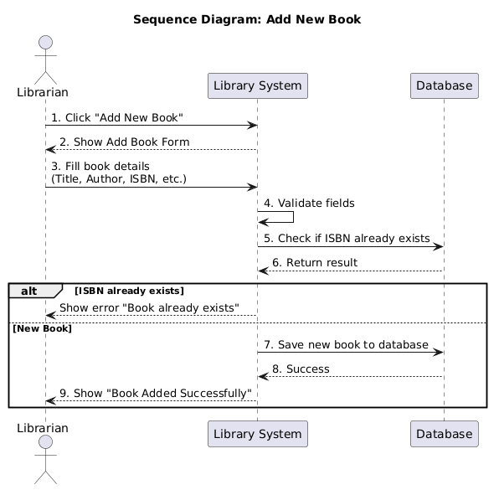
Figure 13: Add New Book Sequence Diagram

- References
[1] K. E. Wiegers, Software Requirements, 2nd ed. Redmond, WA, USA: Microsoft Press, 2003.
[2] R. Elmasri and S. B. Navathe, Fundamentals of Database Systems, 7th ed. Boston, MA, USA: Pearson Education, 2016.
[3] M. Jackson, Software Requirements and Specifications: A Lexicon of Practice, Principles and Prejudices. New York, NY, USA: ACM Press, 1995.
[4] R. Mall, Fundamentals of Software Engineering, 5th ed. New Delhi, India: PHI Learning Private Limited, 2018.
[5] R. S. Pressman, Software Engineering: A Practitioner’s Approach, 8th ed. New York, NY, USA: McGraw-Hill Education, 2014.

